**ASSIGNMENT 4 TASK 1**

GATHERING THE COMPANY STOCK HISTORY AND PRESENT DATA AND CALCULATE . ANALYZING AND COMPARING THE PERFORMANCE OF PUBLICLY TRADED COMPANY’S STOCK OVER THE PAST YEAR AND THE PRESENT .

CONTENTS

* **INTRODUCTION**
* **STOCK PRICE DATA**
* **CALCULATION**
* **COMPARISION**
* **ANALYZING**
* **CONCLUSION**

# **INTRODUCTION :**

**COMPANY NAME : SAMSUNG**



Samsung Electronics Co., Ltd. is a South Korean multinational major appliance and consumer electronics corporation headquartered in Yeongtong-gu, Suwon, South Korea. It is currently the pinnacle of the Samsung chaebol, accounting for 70% of the group's revenue in 2012.

**Samsung**, South Korean company that is one of the world’s largest producers of electronic devices. Samsung specializes in the production of a wide variety of consumer and industry [electronics](https://www.britannica.com/technology/electronics), including [appliances](https://www.britannica.com/technology/home-appliance), digital media devices, [semiconductors](https://www.britannica.com/science/semiconductor), memory chips, and [integrated](https://www.merriam-webster.com/dictionary/integrated) systems. It has become one of the most-recognizable names in technology and produces about a fifth of [South Korea’s](https://www.britannica.com/place/South-Korea) total exports.

Samsung first entered the electronics industry in 1969 with several electronics-focused divisions. Their first products were black-and-white [televisions](https://www.britannica.com/technology/television-technology). During the 1970s the company began to export home electronics products overseas. At that time Samsung was already a major manufacturer in Korea, and it had acquired a 50 percent stake in Korea Semiconductor.

# **STOCK PRICE DATA :**

CURRENT STOCK PRICE DATA :

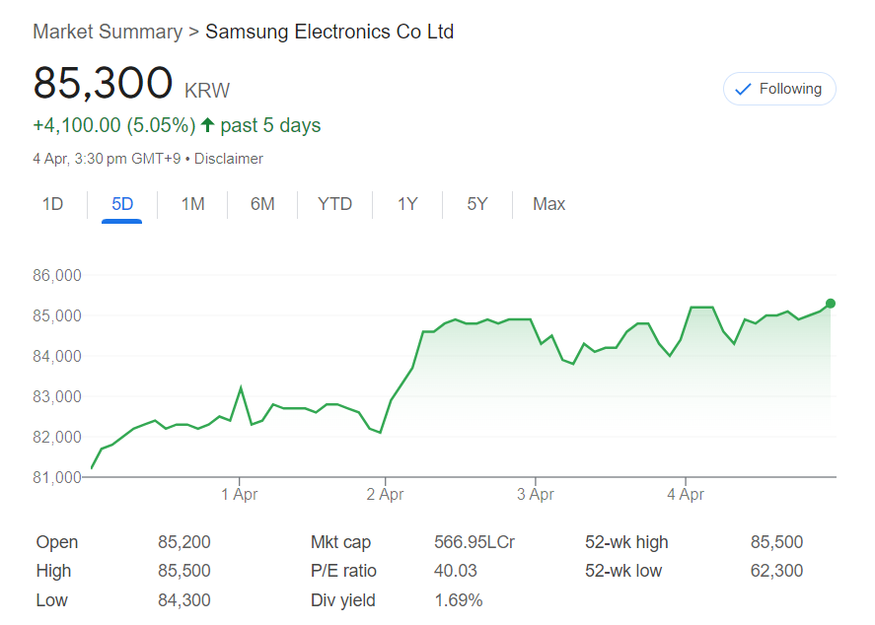

HISTORICAL STOCK PRICE DATA (LAST 5 YEARS) :

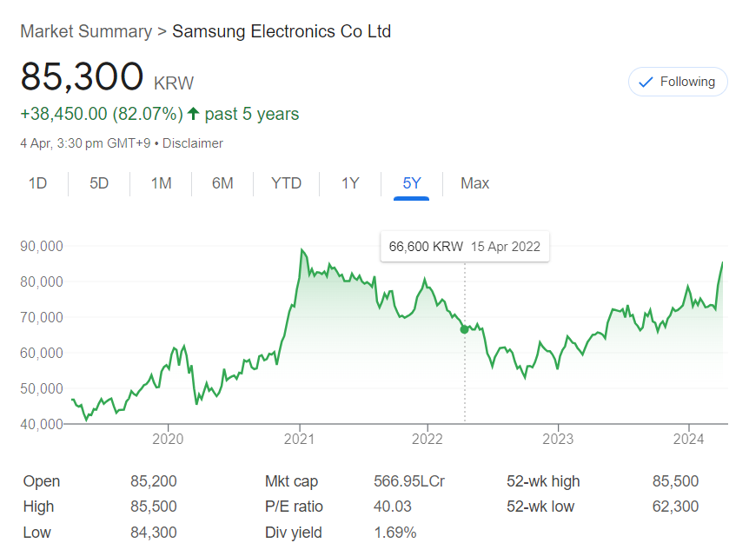

# **CALCULATION :**

Key metrics for assessing SAMSUNG performance typically include financial, operational, and market-related indicators. Here are some of the key metrics commonly used to evaluate SAMSUNG:

1. **Revenue**: Total income generated by SAMSUNG from its sales of products and services.
2. **Net Income**: The profit made by SAMSUNG after deducting all expenses from its revenue.
3. **Gross Margin**: Percentage of revenue remaining after deducting the cost of goods sold (COGS).
4. **Operating Margin**: Operating income expressed as a percentage of revenue, indicating the efficiency of SAMSUNG operations.
5. **EPS (Earnings Per Share)**: Net income divided by the total number of outstanding shares, indicating the portion of profit allocated to each share of SAMSUNG common stock.
6. **Cash and Cash Equivalents**: Amount of cash and assets easily convertible into cash held by SAMSUNG, reflecting its liquidity position.
7. **Debt Levels**: Total debt obligations of SAMSUNG, including long-term and short-term debt, compared to its equity and cash reserves.

* **HISTORICAL DATA :**

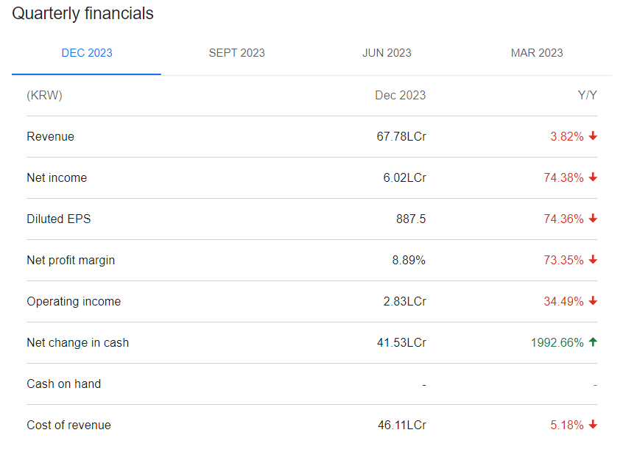

Samsung Electronics Co., Ltd. reported earnings results for the fourth quarter and full year ended December 31, 2023. For the fourth quarter, the company reported sales was KRW 67,780,000 million compared to KRW 70,460,000 million a year ago. Net income was KRW 6,020,000 million compared to KRW 23,500,000 million a year ago. Basic earnings per share from continuing operations was KRW 887 compared to KRW 3,460 a year ago.For the full year, sales was KRW 258,940,000 million compared to KRW 302,230,000 million a year ago. Net income was KRW 14,470,000 million compared to KRW 54,730,000 million a year ago. Basic earnings per share from continuing operations was KRW 2,131 compared to KRW 8,057 a year ago.

* **CHANGE IN STOCK PRICE FROM BEGINNING TO END OF THE YEAR :**

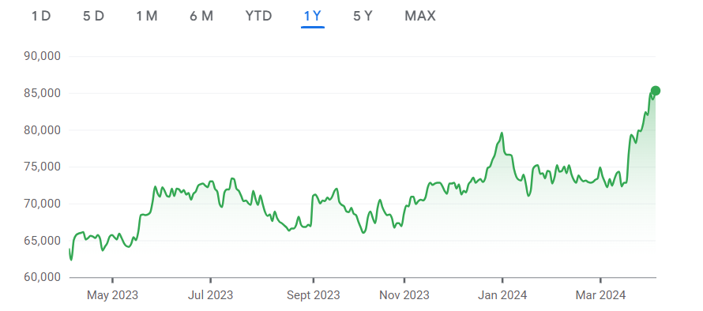

**Current percentage change in stock price :**

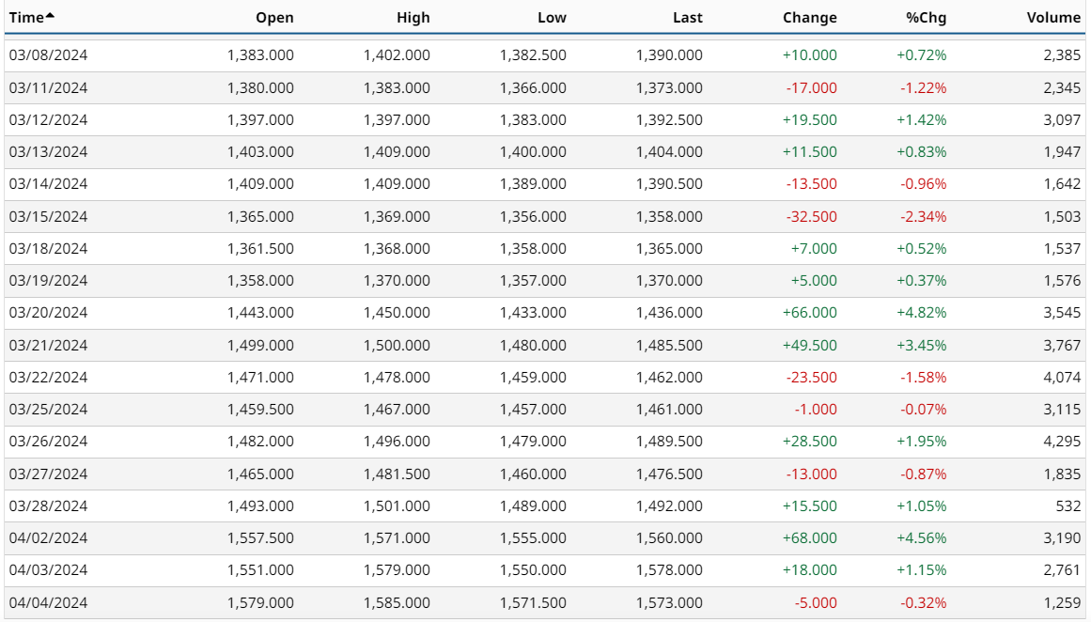

* **VOLTALITIY :**

Volatility is a statistical measure of the dispersion of returns for a given security or market index, it shows how the price swings around its mean. The volatility here is measured as the annualized standard deviation between monthly returns from the security over the past year. In most cases, the higher the volatility, the riskier the security.

As of **today** (2024-04-04), Samsung Electronics Co's Volatility is **20.64%**.

**Samsung Electronics Co Volatility Distribution :**

For the **Hardware** industry and **Technology** sector, Samsung Electronics Co's Volatility distribution charts can be found below:

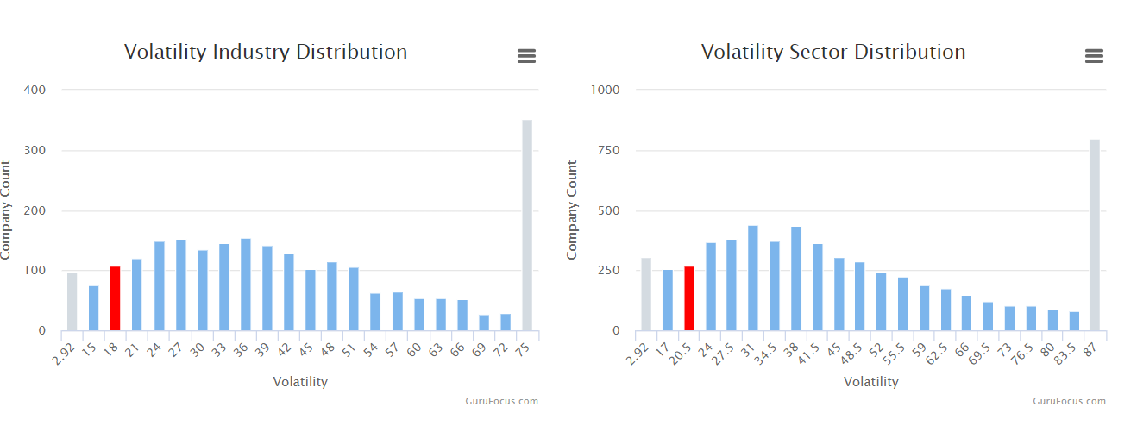

The intrinsic value of one  **Samsung Electronics Co Ltd** stock under the base case scenario is 76 994.78 KRW. Compared to the current market price of 85 100 KRW, Samsung Electronics Co Ltd is **overvalued by 10%**.

* **AVERAGE TRADE VOLUME :**

Metrics similar to **Trading Volume** in the **Valuation** category include:

* [Price / NCAV](https://finbox.com/DB:SSU/explorer/price_to_ncav) - Compares the current stock price to the Net Current Asset Value (NCAV) where NCAV equals the company's Current Assets minus its Total Liabilities.
* [Foreign Exchange Rate](https://finbox.com/DB:SSU/explorer/fx_rate) - The foreign exchange rate between two currencies.
* [Market Cap / Fwd AFFO](https://finbox.com/DB:SSU/explorer/market_to_affo_fwd) - Indicates the multiple of projected adjusted funds from operations (AFFO) that stock investors are willing to pay for one share of the firm.
* [Ben Graham Formula Upside](https://finbox.com/DB:SSU/explorer/ben_graham_upside) - The percentage increase (if positive) or decrease (if negative) an investor can expect over the current stock price based on the Ben Graham Formula Value. The Ben Graham Formula Value estimates a stock's intrinsic value based on a formula inspired by investor and professor, Benjamin Graham.

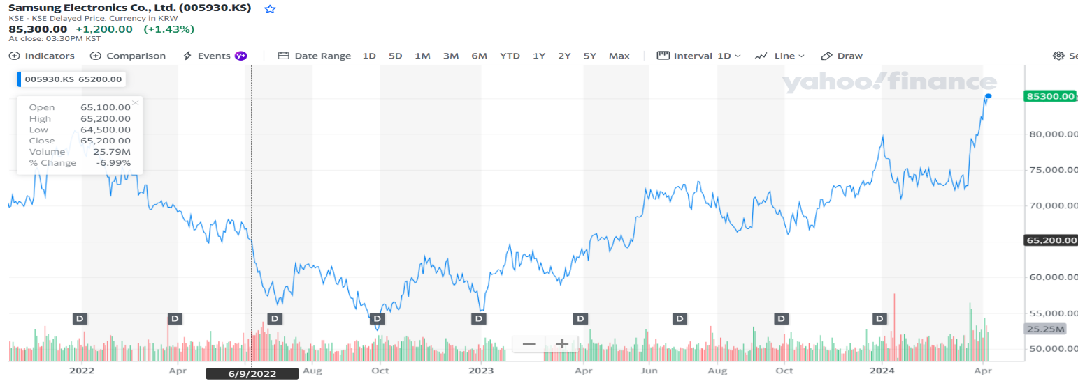

* **COMPARISON OF STOCK :**

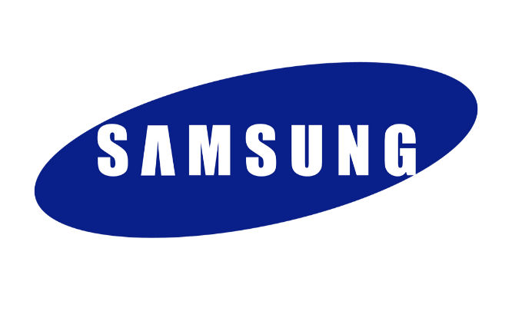

**VS**

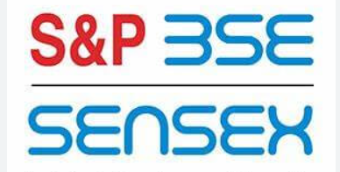

company : SAMSUNG BSE sensex

|  |  |  |
| --- | --- | --- |
| BASIS | SAMSUNG | SENSEX |
| PREVIOUS CLOSE | 84,100.00 | 73,876.82 |
| DAY RANGE | 84,300.00 - 85,500.00 | 73,485.12 - 74,501.73 |
| YEAR RANGE | 62,300.00 - 85,500.00 | 59,094.40 - 74,501.73 |

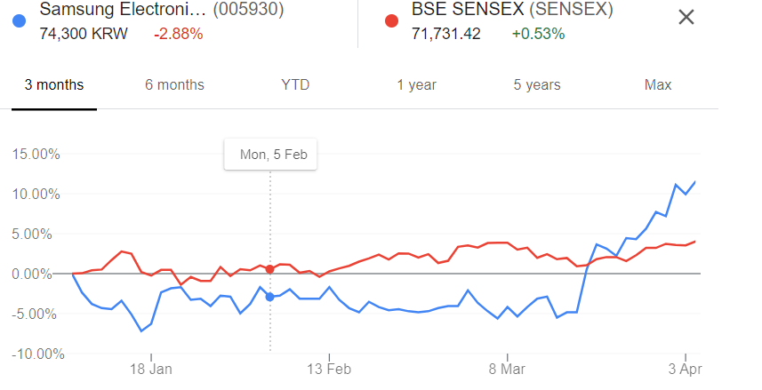

* **ANALYZE :**

Samsung’s business model is characterized by its focus on vertical integration, innovation, and a solid commitment to research and development. Despite facing challenges from competitors and geopolitical tensions, Samsung remains a dominant player in the global market.

A SWOT analysis is a strategic planning tool used to evaluate the Strengths, Weaknesses, Opportunities, and Threats of a business, project, or individual. It involves identifying the internal and external factors that can affect a venture’s success or failure and analyzing them to develop a strategic plan. In this article, we do a SWOT Analysis of Samsung.

* 1. Samsung’s presence in multiple industries, including consumer electronics, semiconductors, display technology, heavy industries, construction, and finance, helps spread risks and create multiple revenue streams. This diversification has contributed to the company’s resilience in economic downturns or market fluctuations.
  2. Samsung has a diversified portfolio, a significant portion of its revenue comes from the highly competitive smartphone market. Overdependence on this segment makes Samsung vulnerable to market fluctuations, intense competition, and changing consumer preferences.
  3. South Korean tech giant Samsung Electronics' stock price plunged on Friday after it was announced that its vice president and heir to the business conglomerate was arrested over his alleged role in a corruption scandal.
  4. Samsung Electronics reported a 95% annual drop in operating profits last quarter as the oversupply of memory chips has sent prices plummeting even after production cuts, though the firm ultimately managed to beat analysts’ earnings projections.
  5. Samsung warned sales and profits of smartphones and TVs are “expected to decline significantly as **COVID-19** affects demand and leads to store and plant closures globally.” It added that there is a possibility it might delay or cut back its investment in 5G technology.
* **CONCLUSION :**

Samsung Electronics Co Ltd's profitability score is 51/100. We take all the information about a company's profitability (such as its margins, capital efficiency, free cash flow generating ability, and more) and consolidate it into one single number - the profitability score.

The robust Samsung marketing strategy has made it one of the most valuable brands today. Its smart digital marketing tactics set an excellent example of how to revamp your online business as a digital marketer.

Its leaders valued speed, scale, and reliability above all. Its marketers set prices and introduced features according to what original-equipment manufacturers wanted. Its engineers built products to meet prescribed price and performance requirements.

Samsung's key success factors for entrepreneurial ventures include their commitment to upgrading technological capabilities, aggressive and risk-taking investment behavior, effective management of technology development, innovation-oriented leadership and culture, customer-focused product innovation and globalization.

**NAME : S.GEETANJALI**

**COLLEGE : DR. LANKAPALLI BULLAYA COLLEGE**